Add A Fee Schedule Entry

Functionality: A Fee schedule entry is a fee schedule item that is based on a percentage of RVRBS. This percentage is set up at the fee schedule level. Once the percentage has been established, the user is able to use this dialogue to add multiple or single procedure codes in one dialogue.

Item | Entry | Action
Fee Schedule ID | User enters ID of Fee Schedule | Look up next to blank, so that user can look it up
CPT Range | From To | Look up for CPT codes
Individual CPTS | User enters CPT separated by commas | Look up for CPT codes and explanation of format
Ok/Cancel | User clicks desired result | Application performs desired results
Next Action | User chooses Next Action | Application performs desired results

Definition of Items

Fee Schedule ID: User enters the ID of the Fee schedule that the entries are linked. This Fee Schedule should have a RVRBS Multiplier already in existence in it.

CPT Range: The user can enter a range of CPT codes that should be entered into a fee schedule, instead of entering them individually. For example if the user needs to enter 99201,99202,99203,99204,99205,99211 etc—instead of entering each code separated by a comma, the user can enter 99201 next to “From” and 99215 next to “To”.

Individual CPT(s): The user can enter in CPT codes that are not listed next to eachother, numerically. For example if the user needs to enter only 99201,99204 and 99215—the user can enter each code, separated by a comma, “99201,99204,99215”.

Ok/Cancel: Ok allows the user to save entries and Cancel escapes out of dialogue and does not save any information.

Next Action: These are a series of choices that the user may choose from to tell the application where they wish to go once the dialogue has been completed and saved.

Action Codes:

Look up Fee Schedule ID: This look up takes user to a search engine for an existing Fee schedule. The user should be able to pull up using the following criteria:
Fee Schedule Name, Fee Schedule ID, Description, Physicians linked to Fee Schedule, Locations linked to Fee schedule

Fee Schedule Name
Fee Schedule ID | **User enters ID * look up for ID
Description
Associated Physicians | **User enters ID(s)* look up for ID
Associated Site Organizations | **User enters ID(s) * look up for ID

Once user clicks [OK]→application pulls up results:

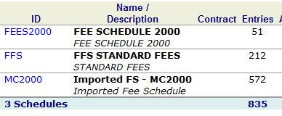
- User clicks look up→application takes user to search engine→user clicks Name/Description (Fee Schedule 2000)→application takes user to details of fee schedule
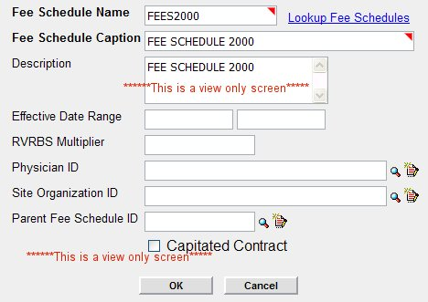
This is a view only screen. →User closes screen→application takes user back to results→user chooses existing Fee Schedule by clicking hyperlink on Fee Schedule ID→application closes results window→application auto fills Fee Schedule ID in Add a Fee Schedule Item dialogue. ****Note: if the RVRBS multiplier is not filled in, then application should pull up a warning stating this→user must click ok for warning to close→application takes user back to Add-a-Fee Schedule Entry Dialogue but does not add the ID into the field. (This will be a training issue—the user will have to leave this dialogue and correct this fee schedule before adding codes). ****Can we do this?

Lookup for CPT Code (Both in range and individual)

The look up should offer the following constraints:
Code type (i.e. HCPCS, CPT etc)
Code name
Code description

Search results should pop up in another window:
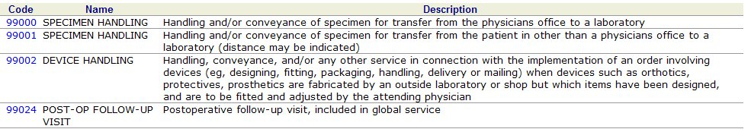

If the user selects the code→application should close window→place code in a blank field at CPT in the Add-a-Fee Schedule Entry dialogue.

***Note: User does not need to look up Code; they should be able to key it in if they know it.

Next Action:

Once the user completes all necessary fields in Add-a-Fee Schedule Entry Dialogue, they should choose a Next Action:

Next Action | Action
Go to Fee Schedule Catalog | Takes user to fee schedule catalog
Add another fee Schedule entry | Takes user to a blank fee schedule entry dialogue
Add a Fee Schedule Item | Takes user to Add-A-Fee schedule item dialogue
Go to Work Lists | Takes user to Work List
Return to Home | Takes user to their Home Page
View Fee schedule | Takes user to Fee schedule in Fee Schedule Id field

Function:

User Clicks [OK] → Application adds Fee Schedule Item→ Application performs Next Action.

